The Thursday’s Gossan porphyry –
It can’t run but it can hide

Chris Cairns ⁽¹⁾, Doug Menzies ⁽²⁾, Greg Corbett ⁽²⁾, Hamish Forgan ⁽¹⁾, Jennifer Murphy ⁽¹⁾
⁽¹⁾Stavely Minerals Limited ⁽²⁾Corbett Menzies Cunliffe Pty Ltd
Key Words: porphyry copper, gold, Mount Stavely Volcanic Complex, Thursday’s Gossan prospect, Lachlan Fold Belt, Victoria, potassic alteration, phyllic alteration, sulphur isotopes, SWNIR

ABSTRACT
The Thursday’s Gossan and Junction prospects are hosted within the volcaniclastic sequence of the Mount Stavely Volcanic Complex (MSVC) in western Victoria, which has been intruded by an early granodiorite, and later feldspar porphyritic tonalite, trondhjemite, and andesite dykes. Whole rock and trace element geochemical analyses of tonalities and trondhjemites led Crawford (2015) to suggest these intrusions have indicators of high copper fertility, and affinities with intrusions from other porphyry Cu-Au deposits. The MSVC sequence and intrusions have undergone early potassic to propylitic alteration, which was overprinted by retrograde phyllic and argillic alteration. Shortwave near infrared (SWIR) and thermal infrared (TIR) spectral analysis of drill core and chips reported the occurrence of kaolinite, smectite and minor amounts of pyrophyllite indicative of deposition from a higher temperature, low pH fluid which produced a concentrically zoned alteration pattern from advanced argillic to intermediate argillic to propylitic.
Chalcopyrite ± molybdenite mineralisation occurs within early wormy and sheeted chalcopyrite-pyrite bearing A, linear chalcopyrite-pyrite bearing B and later massive chalcopyrite-pyrite-molybdenite ± bornite ± bismuthinite ± arsenopyrite ± tennantite-tetrahedrite bearing D porphyry style quartz veins (using the classification of Gustafson and Hunt, 1975). Locally, Cu has been remobilised and upgraded above the base of oxidation by supergene processes to form a chalcocite blanket adjacent to the NNW-SSE orientated Mount Stavely Fault and hosts an estimated Mineral Resource of 28Mt at 0.4% Cu and equates to 110,000 tonnes of copper.
An exploration target, defined as an unseen buried second generation porphyry intrusion, is inferred from the presence of quartz-magnetite bearing E veins which overprint the earlier magnetite destructive retrograde phyllic (sericite) alteration and core-parallel quartz-chalcopyrite-pyrite bearing B veins. This event resulted in the emplacement of sigmoid-shaped, core-parallel pyrite-chalcopyrite-molybdenite-quartz bearing D veins, adjacent to and within a low-angle structural zone. Available data suggests this low-angle normal fault, which dips to SW, has displaced the Thursday’s Gossan sequence with the top block top-S to SE sense of movement, in the order of hundreds of metres to 1-2 km. It is therefore postulated that the structural ‘unroofing’ of the Thursday’s Gossan system, by extension associated with normal movement on low-angle faults, may have led to the emplacement of an unseen, second generation more metal productive resurgent intrusion phase that overprinted earlier phyllic alteration and low grade chalcopyrite-pyrite bearing B veins, with later quartz-magnetite bearing E veins. This is supported by δ34 sulphur isotope results that broadly demonstrate an increasing contribution of magmatically derived negative δ34 sulphur isotopes with depth (-1.4, -2.4, -4.2, -5.5‰), which then decreases beneath the flat-lying structural zone (-3.0‰), and suggests the syn-mineral structural evolution of the hydrothermal system. Consistently, SWNIR and TIR spectral analysis of drill core highlight a pattern of shorter wavelength white mica absorption features, interpreted to have resulted from low-pH magmatic dominant fluids, that; a) above the structural zone become progressively stronger to the south, whereas b) beneath the flat-lying structure there is a clear pattern of progressively shorter wavelength white mica absorption features to the north. Given the observed positive correlation between elevated IP chargeability and phyllic alteration, additional induced polarization (IP) geophysical programs are planned to target better developed copper-gold mineralization likely to be associated with potassic alteration beneath the low-angle structural zone.

REGIONAL GEOLOGY
The Thursday’s Gossan and Junction porphyry copper prospects are hosted within the Lower to Mid Cambrian Mount Stavely Volcanic Complex (MSVC) of the Grampians-Stavely Zone in western Victoria (Figure 1), which comprises five volcano-sedimentary stratigraphic and intrusive units, namely: the Fairview Andesite Breccia, the Lalkaldarno Porphyry, Nanapundah Tuff, Towanway Tuff and the Williamsons Road Serpentinite (Buckland, 1987 and Geoscience Australia, 2013). The stratigraphy has been uplifted, folded, faulted and tilted during the Delamarian Orogeny (Crawford et al., 2003), the timing of which is constrained by the post-tectonic intrusion of the Bushy Creek Igneous Complex dated at 489 ± 7 Ma (Stuart-Smith and Black, 1999). The basal Fairview Andesite Breccia consists of massive, poorly sorted, matrix supported green volcanic breccia, with intercalated andesite and basalt, and a black pyritic shale and volcanic siltstone of the Glenronald Shale Member (Buckland, 1987). The Fairview Andesite Breccia is overlain by poor to moderately sorted dark green andesitic volcanic sandstone of the Nanapundah Tuff, which is in turn overlain by the dacitic crystal lithic volcanic sandstone and siltstone of the Towanway Tuff, and the dacite to rhyolite lavas of the Narrapumelap Road Dacite Member. The Mount Stavely Volcanic Complex is bounded to the E by the Williamsons Road Serpentinite, and the sequence has been intruded by the post-mineral porphyritic hornblende quartz diorite of the Lalkaldarno Porphyry (500 ± 2 Ma) (Buckland, 1987, Geoscience Australia, 2014).

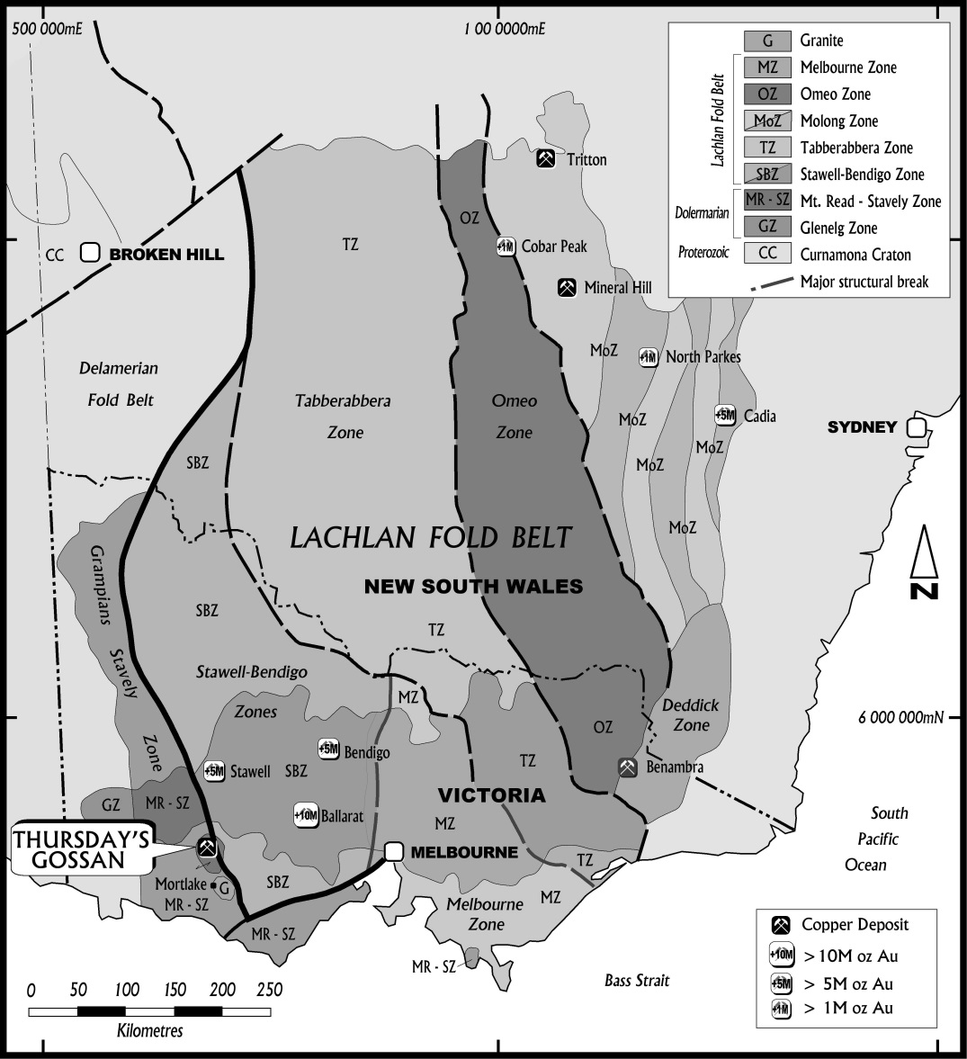
Figure 1. South-east Australian geology showing the location of the Thursday’s Gossan and Junction porphyry prospects.

LOCAL GEOLOGY
The uppermost unit intersected in holes drilled into the Thursday’s Gossan prospect is a massive sequence of white, fine to medium grained sandstone with interbedded siltstone of the Glenthompson Sandstone. The Glenthompson Sandstone overlies the Fairview Andesite which displays auto brecciated, re-sedimented and peperitic textures indicative of emplacement as a hyaloclastite lava or syn-volcanic intrusion (McPhie et al, 1993), and locally grades into a massive monomictic andesite breccia. Serpentinite intersected in several drill holes on the eastern side of the prospect is interpreted to be part of the Williamsons Road Serpentinite that was reported by Crawford (1988) and Crawford et al. (2003) to have high Ca boninite affinities. The MSVC sequence has been intruded by an early granodiorite, and later feldspar porphyritic tonalite, trondhjemite and andesite dykes, and a feldspar, needle-hornblende porphyritic dacite. The latest intrusion is an unaltered feldspar porphyritic dyke which has similarities to the Late Cambrian Lalkaldarno porphyry (500 ± 2 Ma, Buckland and Ramsay 1982). Discussions with other workers (Crawford, Taylor and Cayley, pers comm 2014), and given the error margins of recent age dates, suggest the emplacement of porphyry intrusions within the Stavely belt may be contemporaneous with the Bushy Creek batholith (497±7Ma) which post-dates and, based on the aeromagnetic character, was not substantially tilted by regional deformation (Figures 2 & 3). Maintenance of the original upright orientation allows Pacific rim porphyry models (Corbett, in prep) to be used in Stavely exploration. Whole rock and trace element geochemical analyses of tonalities and trondhjemites led Crawford (2015) to suggest these intrusions have indicators of high copper fertility and affinities with intrusions from other porphyry Cu-Au deposits (Figure 5). An increased thickness of well laminated, medium grained, feldspathic sandstones and siltstone in drill holes bored into the southern and western parts of Thursday’s Gossan prospect, and to the south in the Junction prospect, indicates the andesite lavas of the MSVC’s thin to the S. In the southern part of Thursday’s Gossan prospect a massive thickness of fault-bounded sandstone may suggest syn-depositional normal (growth) faults were active.
Recent Re-Os dating of molybdenite in ‘D veins’ from the Thursday’s Gossan porphyry prospect has returned a date of 503.2 ±1.7Ma and from the Junction porphyry prospect an age of 500.6 ± 1.7Ma indicating near contemporaneous emplacement of the Bushy Creek Igneous Complex (489 ± 7 Ma) with the intrusions responsible for porphyry-style mineralization at these prospects (Huston and Norman, unpublished data) and Schofield et al., 2015. One additional younger date of 476 ± 4.4 Ma from a tonalite porphyry with weak propylitic alteration intercepted in drill core from SMD001 is not yet corroborated by any other data to date.
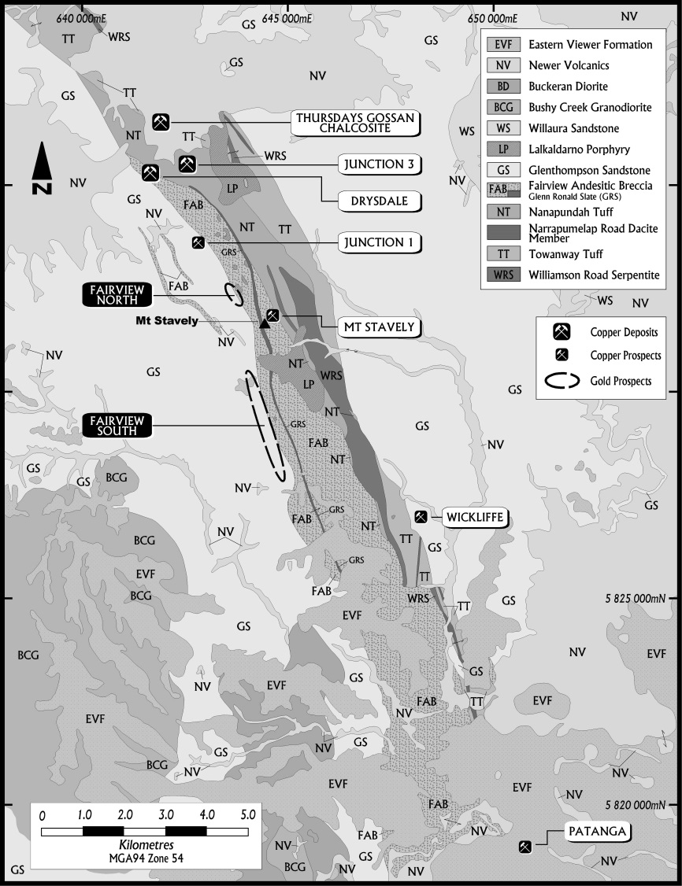
Figure 2. Local geology of the MSVC showing porphyry prospect locations. Wickliffe is a VMS prospect.
It should be noted that, with the exception of the Bushy Creek Igneous Complex, all pre-tectonic stratigraphic contacts are faulted. A logical stratigraphy would have the Williamsons Road Serpentinite as the basal unit as primitive sea floor followed by the tuffs and andesite breccia with the continental-derived Glenthompson Sandstone turbidite sequence as the youngest depositional unit which are then intruded by the Lalkaldarno Porphyry with later intrusive phases including the Bushy Creek Igneous complex (and implied porphyry equivalents) and related mafic sills intruding the Glenthompson Sandstone (Schofield et al., 2015) (Figure 2 legend). Observed field relationships are the product of structural transposition both during the Cambrian and a later Silurian deformation which has resulted in the largely structural emplacement of the overlying Late Ordovician to Silurian-aged Grampians Group sediments.

Structural geology
It is hypothesized, based on a SE-NW trend for subduction and compression, that sinistral movement along the N-S trending Mt Stavely and Escondida Faults, evident on aeromagnetic data and published geological maps (Figures 2, 3 and 4), would have facilitated dilation along the NW trending off-sets seen in the regional aeromagnetic data. Many ore systems in the Lachlan Fold Belt are localised by sinistral movement on the roughly NS arc-parallel structures (Corbett and Leach, 1998; Corbett, 2013) and sinsitral movement at Stavey would have provided a strongly dilatant WNW trending site for the emplacement of the intrusions inferred from the gravity lows seen in Figure 4. Many porphyry systems are localised at splays or other dilatant segments in arc-parallel structures (Chuquicamata, Chile; Lepanto, Philippines; Frieda, Papua New Guinea; Corbett, in prep). The NW trending structures display a through-going character and so possibly represent arc-orthogonal transfer structures as defined by Corbett and Leach (1998) formed as major breaks normal to the arc which host porphyry systems in settings such as the Cadia-Ridgeway in NSW where intrusions are aligned along the Lachlan Transverse Zone and the Wafi-Golpu Cu-Au porphyry emplaced within the Wafi transfer structure in Papua New Guinea (Menzies, et al. 2013). Structural studies by Stavely Minerals geologists (unpublished 2014), Menzies and Corbett (2014) and Neilsen and Augenstein (2015) propose that general geometry of the copper porphyry system is likely to be upright and not folded, and offset by at least two low-angle normal faults that dip NW to SW and have displaced the top block to S-SE, in the order of hundreds of metres to 1-2km (Neilsen and Augenstein, 2015).

Hydrothermal alteration.
The Williamsons Road Serpentinite ultramafic units have undergone intense, pervasive serpentinite and talc alteration which has destroyed most of the original rock texture and has possibly occurred during regional deformation. Andesite lavas and volcaniclastic breccias of the Fairview Andesite display weak to moderate pervasive chlorite alteration possibly formed during diagenesis and compaction of the volcanic pile (McPhie et al, 1993) or maybe porphyry-related outer propylitic alteration.
Several drill holes exhibit moderate to strong, vein selvage and pervasive prograde biotite alteration indicative of proximal-to-porphyry environment potassic alteration. Biotite-magnetite alteration is often prevalent in permeable, medium grained sandstones in the lower part of the sequence which have facilitated the migration of high temperature potassic fluids further from the magmatic source. This is similar to that described by Cook et al (2007) in the porous Ordovician volcaniclastic units around the Goonumbla E48 porphyry Cu-Au deposit north Parkes, NSW. Vein and disseminated actinolite ± albite occurs on the margins of biotite rich alteration zones which grades out into epidote veins. Locally, quartz veins exhibit K-feldspar ± albite selvages often with biotite altered groundmass. Pervasive hematite alteration is evident in porous volcaniclastic units and sandstones coating feldspar grains.
Drill holes SMD002 and SMD005, bored into the Junction prospect, locally exhibit moderately developed garnet-actinolite-epidote-chlorite-magnetite skarn-style alteration (Ashley, 2015) within monomictic andesite breccia, which was produced by high temperature magmatic fluids possibly migrated within permeable rock units from a distal intrusion source. Minor K-feldspar-magnetite alteration occurs within monomictic andesite breccia and weak biotite-magnetite alteration is recognised within porous volcaniclastic sandstone breccia intersected in drill hole SMD002. The 3D structural model of the local area suggests the Junction porphyry is similarly impacted by the low-angle structural zone as is the Thursday’s Gossan porphyry.

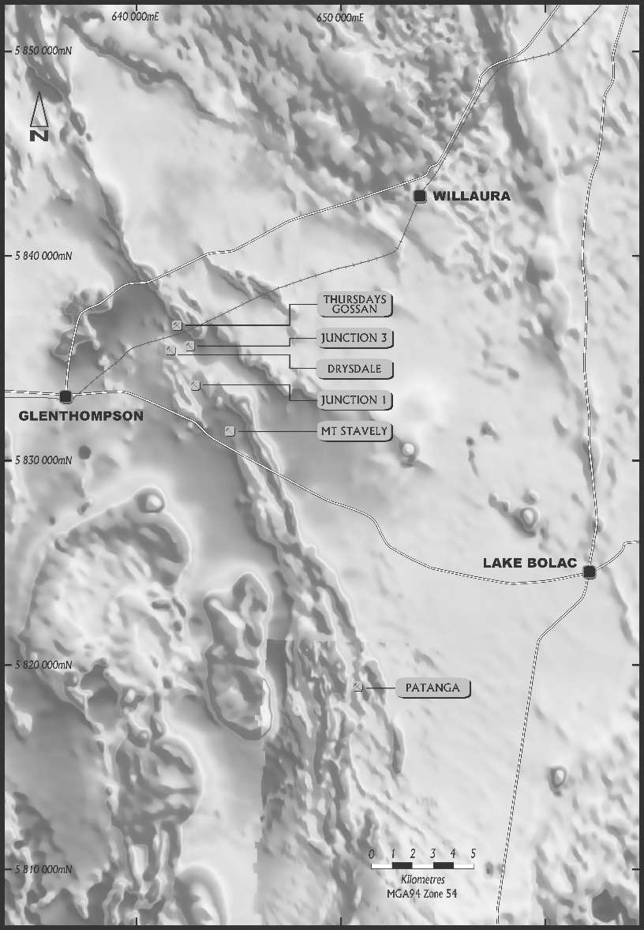 | 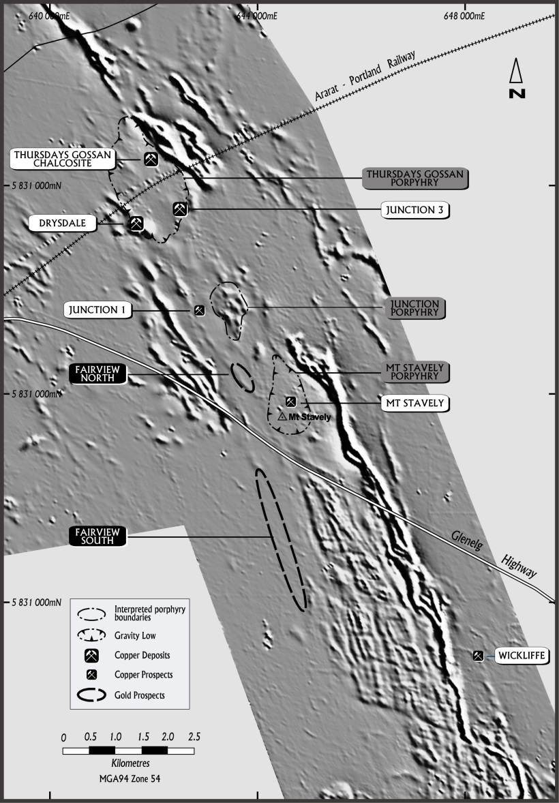
Figure 3. Regional aeromagnetic image. Note the MSVC in a N-S to NNW orientation through the centre of the image while prominent NW structures are observed in the vicinity of Lake Bolac and Willaura. The concentric zoned intrusion west of the Patanga prospect is the Bushy Creek Intrusive Complex. | Figure 4. Greyscale airborne magnetic data overlain with Bouger gravity colour drape. Note the NW structural offset in the SE corner of the image. The high-amplitude magnetic unit in the eastern margin of the belt is the Williamsons Road Serpentinite.

Figure 5. Discriminant plots for the Lalkaldarno tonalite-trondhjemite porphyries showing fertile signature for this intrusive suite, which is comagmatic with that sampled in SMD001 and elsewhere at Thursday’s Gossan. Only a late andesite dyke in SMD001 at 442.6m plots out of the fertile field. (Crawford, 2015).
Intense sericite-carbonate alteration, associated with up to 5% disseminated pyrite, is strong to intensely developed in granodiorite, and is often most intense around fault zones and where it obliterates earlier biotite ± K-feldspar alteration. In the upper parts of the system kaolinite-pyrophyllite alteration overprints earlier sericite-carbonate alteration.
The upper parts of diamond cored drill holes, and chips from aircore holes, bored into both the Thursday’s Gossan and Junction prospects, exhibit white clay alteration which, when analysed spectrographically by Spencer (1996), returned kaolinite, smectite and minor amounts of pyrophyllite, defined a concentric alteration zonation from advanced argillic, intermediate argillic, phyllic and propylitic (Figure 6).
Hylogger analysis of historical diamond-cored drill holes by Lynch and Huntington (2011) which, along with SWNIR spectral data collected from recent drill holes with a hand-held Terraspec Halo® by Stavely Minerals, was reinterpreted by Halley (2013, 2014) who reported a distribution of alteration minerals that broadly correlated with empirically observed alteration types of outer potassic, propylitic and phyllic, with lesser distal advanced argillic alteration. This SWIR and TIR spectral analysis also highlighted a pattern of shorter wavelength white mica absorption features interpreted to have resulted from low-pH magmatic dominant fluids that a) above the structural zone become progressively stronger to the south, and, b) beneath the flat-lying normal structure there is a clear pattern of progressively shorter wavelength white mica absorption features to the north (Figure 7).
It is interpreted that circulating cells of hydrothermal fluids driven by a porphyry heat source at depth have carried exsolved volatiles above the intrusion where they condensed and mixed with ground waters to form a sink of hot acid fluids. In response to progressive cooling of the porphyry system the outward moving circulating hydrothermal cells reversed, and drawdown caused collapse of acidic evolved meteoric waters from above the porphyry onto the pre-existing alteration which facilitated the overprinting

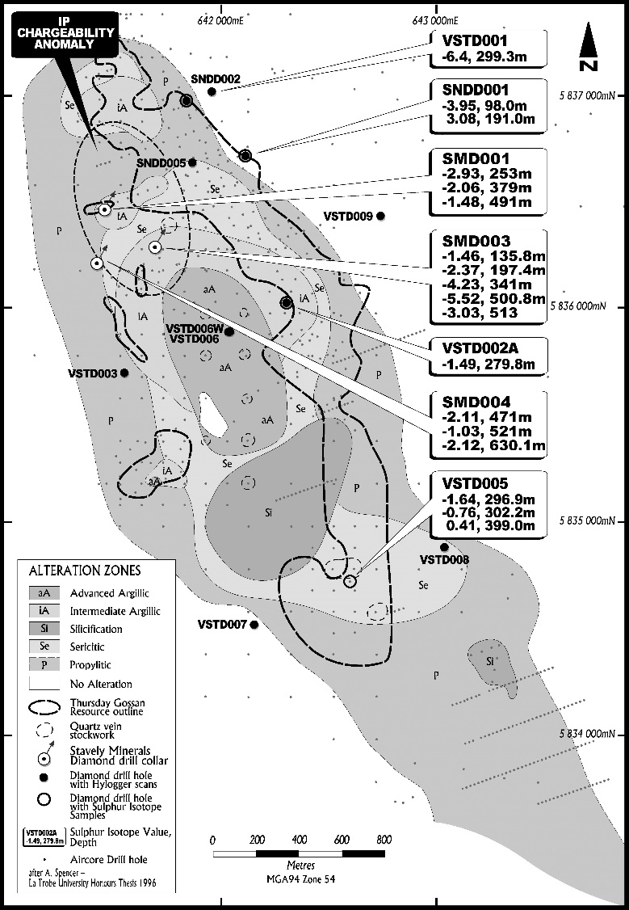
Figure 6. Distribution of alteration types after Spencer, 1996. Hole collars are those holes with HyLogger® or Terraspec Halo® SWNIR readings. Drill holes with sulphur isotope analyses are annotated with δ34 S values per mil and depth the sample was taken.
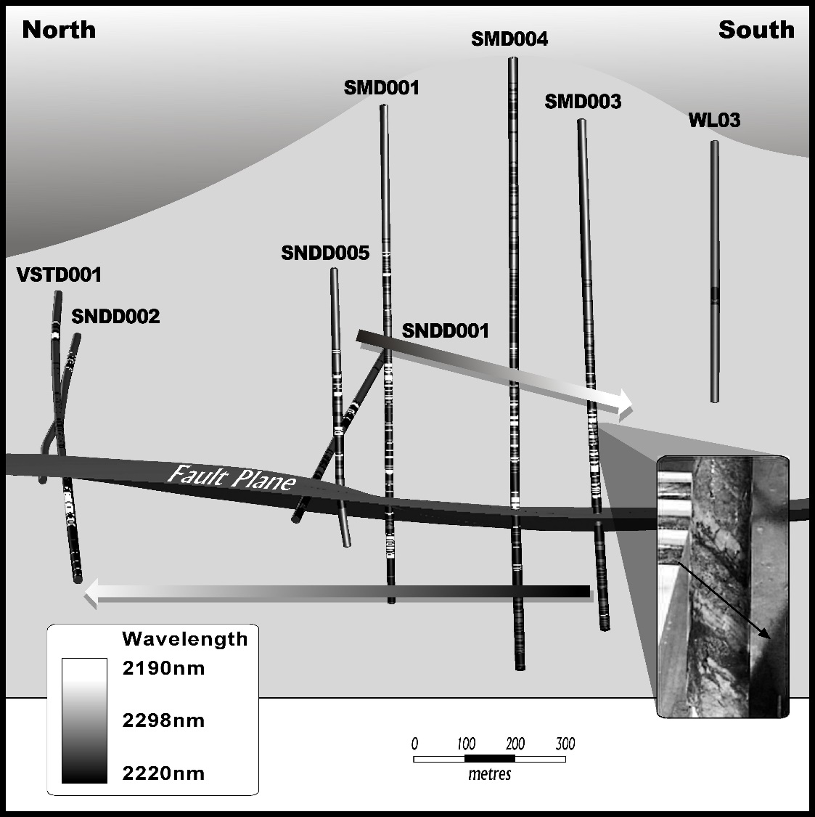
Figure 7. Thursday’s Gossan diamond drill holes showing white mica wavelengths. View is along the plane of the low-angle structure looking to the ENE.

of phyllic (silica-sericite-pyrite) on potassic (biotite-magnetite ± actiolite ± K-feldspar-albite) and propylitic (chlorite-epidote) alteration. This late phyllic alteration was then overprinted by later argillic (pyrophyllite-kaolinite + illite) alteration as the acid waters underwent cooling and became more acidic which resulted in a composite of sericite-clay alteration.

Mineralisation
A flat lying blanket of secondary Cu enrichment has been defined at Thursday’s Gossan which extends for 4km N-S and 1.5km E-W, and contains approximately 28Mt at 0.4% Cu and equates to 110,000 tonnes of copper (Stavely Prospectus, 2014). Chalcocite and covellite occurs as disseminations and on pyrite rims within the Glenthompson Sandstone and Fairview Andesite between the base of oxidation and a surficial depleted zone and is bounded by the NNW-SSE oriented Mount Stavely Fault.
While minor occurrences of chalcopyrite-pyrite-bearing porphyry style B veins which cut earlier sheeted and ptygmatic quartz-K-feldspar-chalcopyrite bearing A veins are present within biotite-actinolite altered andesite, the dominate veins are massive pyrite ± chalcopyrite ± molybdenite bearing D veins (using the classification of Gustafson and Hunt 1975), up to 5m wide, intersected within zones of moderate to strong sericite alteration. A zone of intense D vein mineralisation reported 28m at 0.15% Cu from 251m in drill hole SMD001 associated with sericite overprinted on biotite alteration. Locally these D veins host minor amounts of bornite ± bismuthinite ± arsenopyrite ± tennantite-tetrahedite (Ashley, 2015) which is most prominent in SMD003 (196m at 0.13% Cu from 322m). Minor pyrite-magnetite-chalcopyrite bearing E veins (using the classification of Corbett, in prep) are present within sericite altered granodiorite which cut core-parallel quartz-chalcopyrite-pyrite bearing B veins, and suggest deposition from hydrothermal fluids derived from a later intrusion phase after the cessation of the earlier magnetite destructive sericite alteration. The core parallel B veins, which have a NE strike based on oriented core measurements, suggests NE-SW compression or NW-SE extension controlled mineralisation. Pyrite-chalcopyrite ± molybdenite bearing quartz D veins display sigmoidal shapes parallel to the core axis formed by normal movement on low-angle WSW dipping faults, possibly related to porphyry ‘unroofing’.
In drill holes SMD001, SMD003 and SMD004, all bored to test a large 30mv/v induced polarization chargeability anomaly, phyllic alteration (sericite, silica, pyrite) correlated well with the modelled position of the zone of elevated chargeability. While phyllic alteration was observed as an overprint on earlier prograde propyllitic / potassic (biotite) alteration above the low-angle normal structure, alteration in each hole the below the structural zone was characterized as propylitic to outer propylitic alteration. While there is a marked change in alteration mineralogy below the low-angle normal fault, chalcopyrite occurs both above, below and within the structural zone indicating that Cu mineralisation probably continued temporally at least up to activation of this structural zone if not as a consequence of its activation. It is postulated that structural ‘unroofing’ of the system may have led to the emplacement of an unseen more metal productive resurgent intrusion at depth with this intrusion responsible for the copper mineralised veins which overprint earlier alteration within the overlying wall rocks.

Sulphur Isotope Data
Sulphur isotope data has been collected for 23 samples from 8 diamond drill holes at the Thursday’s Gossan prospect. Geoscience Australia collected 12 samples from 5 diamond drill holes in late 2013 and an addition 11 samples from 3 diamond drill holes were gathered by Stavely Minerals in late 2014. All samples were sent to the Central Science Laboratory at the University of Tasmania for δ34 sulphur isotope analysis.
The δ34 sulphur isotope results range from 3.08‰ to -21.86‰ with an average of -3.44 and, with the removal of upper and lower outliers, results in a range from -0.76‰ to -6.4‰ δ34 sulphur (Figure 6). The highest result of -21.9‰ may be spurious as it is so strongly negative relative to all the other results, while the 3.08‰ result is likely to be syngenetic sulphide given the host is a sequence of interbedded submarine sequence of volcanics and sediments where seawater sulphur is prevalent. The δ34 sulphur isotope results (Figure 6) broadly demonstrate increasingly negative δ34 sulphur isotopes in SMD003 as it progresses to depth (-1.4, -2.4, -4.2, -5.5‰) until the flat-lying normal fault below which values decrease (-3.0‰). The most negative δ34 sulphur isotope results reported from the Thursday’s Gossan prospect (-21.9‰ and -6.4‰) are in VSTD001 in the northern part of the prospect. The range of sulphur isotope values reported from Thursday’s Gossan prospect (-0.76‰ to -6.4‰) are consistent with δ34 sulphur isotope results from alkalic copper-gold porphyry systems of economic significance in central New South Wales and British Columbia (Holliday and Cooke, 2007 and Deyell and Tosdal, 2005).

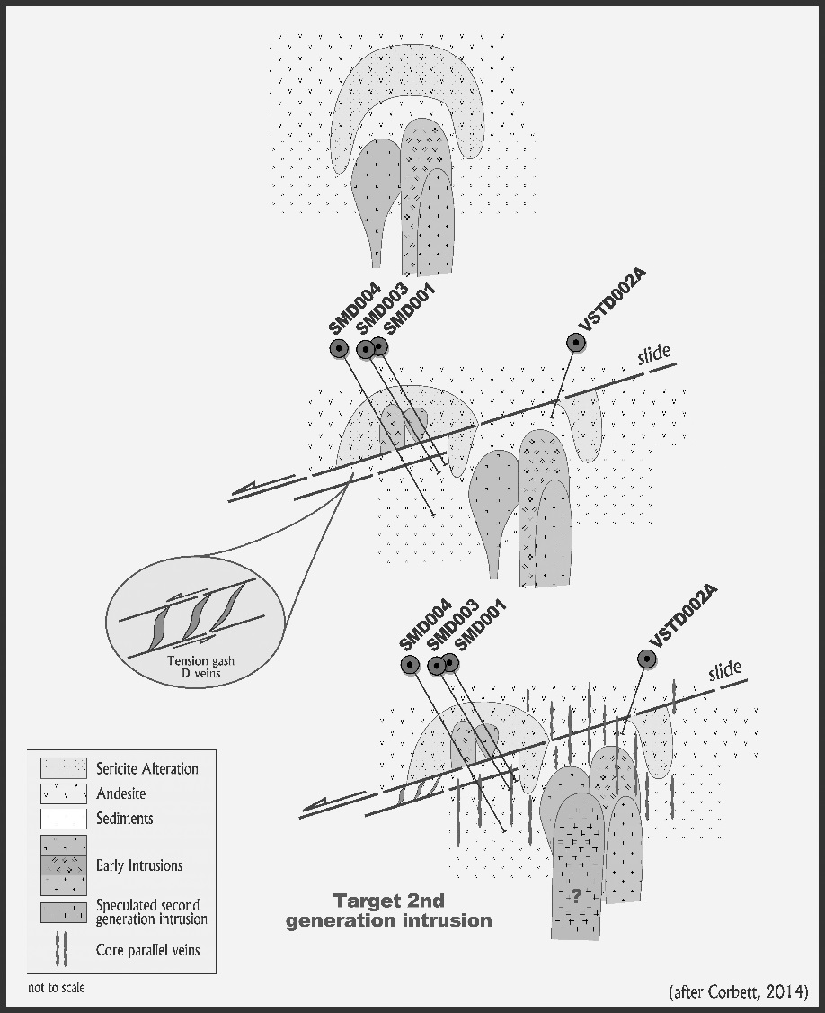
Figure 8. Conceptual model for unroofing of the Thursday’s Gossan prospect by a WSW dipping normal fault which triggered the emplacement of a second generation intrusion and development of tension gash D veins.

Induced Polarisation surveys results
Several dipole – dipole Induced Polarisation (IP) surveys were completed by Search Exploration Pty Ltd in 2013, 2014 and 2015 using a 50 kVA transmitter with 100 metre dipole separation on nominal 400 metre line spacing. A deep elevated IP chargeability (>25mV/V ) anomaly was identified at n-levels greater than 6 located to the north of the advanced argillic alteration zone identified through PIMA logging of aircore drill holes (Figure 6). This chargeability feature was interpreted as likely reflecting disseminated pyrite associated with retrograde phyllic alteration overprinting earlier prograde potassic / propylitic alteration (Ebner, 2014). Recent drilling was targeted to bore through the chargeability feature and prospect for potassic alteration at depth.

Conclusions
The Thursday’s Gossan porphyry and Junction porphyry copper prospect is hosted within the Lower to Mid-Cambrian andesite volcanics and volcaniclastics of the Mount Stavely Volcanic Complex (MSVC), has been intruded by an early granodiorite, and later feldspar porphyritic tonalite, trondhjemite, andesite dykes, and a late feldspar, needle-hornblende porphyritic dacite, and is interpreted that have been localised by sinistral movement on prominent NS oriented structures. The MSVC sequence and intrusions have undergone early potassic to propylitic alteration, which was overprinted by retrograde phyllic and argillic alteration. Whole rock and trace element geochemical analyses of tonalities and trondhjemites has led Crawford (2015) to suggest these intrusions have indicators of high copper fertility and affinities with intrusions from other porphyry Cu-Au deposits.
Chalcopyrite ± molybdenite mineralisation occurs within early wormy and sheeted chalcopyrite-pyrite bearing A, linear chalcopyrite-pyrite bearing B and later massive chalcopyrite-pyrite-molybdenite ± bornite ± bismuthinite ± arsenopyrite ± tennantite-tetrahedite bearing D porphyry style quartz veins using the classification of Gustafson and Hunt (1975). An exploration target, defined as an unseen buried second generation porphyry intrusion, is inferred from the presence of quartz-magnetite bearing E veins which overprint the earlier magnetite destructive retrograde phyllic (sericite) alteration and core-parallel quartz-chalcopyrite-pyrite bearing B veins. This event also resulted in the emplacement of sigmoid-shaped, core-parallel pyrite-chalcopyrite-molybdenite-quartz bearing D veins, adjacent to a low-angle structural zone. It is therefore postulated that the structural ‘unroofing’ of the system by extension associated with normal movement on low-angle faults may have led to the emplacement of an unseen, second generation more metal productive resurgent intrusion that overprinted earlier phyllic alteration and low grade chalcopyrite-pyrite bearing B veins, with later quartz-magnetite bearing E veins (Figure 8). The broad distribution of sulphur isotope values, the SWNIR white mica absorption wavelengths and kinematic indicators from structural logging concur with a lower block north to north-east structural transposition.
Additional induced polarization geophysical programs are planned, given the previous excellent correlation between IP chargeability features and phyllic alteration, to target better developed copper-gold mineralization likely to be associated with potassic alteration transposed beneath the low-angle structural zone.

References
Ashley P. M., 2015 Petrographic report on a hundred and one drill core samples from EL4556, Glen Thompson region, western Victoria, an unpublished report by Paul Ashley Petrographic and Geological Services for Stavely Minerals Ltd.
Buckland, G.L., 1987 Geology and mineral potential of the Mount Stavely Volcanic Complex., Geological Survey of Victoria. Report 80.
Buckland, G.L. and Ramsay, W.R.H. 1982 The geological setting and mineral potential of the Mount Stavely Volcanic Complex, Western Victoria. IN Melbourne Conference, 1982. AusIMM 1v p419-432
Cooke, D.R., Wilson, A.J., House, M.J.,Wolfe,R..C. Walshe,J.L., Lickfold, V. and Crawford, A.J., 2007, Alkalic porphyry Au – Cu and associated mineral deposits of the Ordivician to Early Silurian Macquarie Arc, New South Wales, Australian Journal of Earth Sciences: An Internationsl Geoscience Journal of the Geological Society of Australia, 54:2-3, 445-463.
Corbett, G.J., 2013, Tasmanides arc style Au-Cu mineralisation in a Pacific rim setting: Mines and Wines Conference, Australian Institute of Geoscientists Bulletin 55, p. 23-32.
Corbett, G.J., in prep, Epithermal and porphyry ore deposits – Field aspects for explorationists: Short Course manual, Australian Institute of Geoscientists, Bulletin .
Corbett, G.J., and Leach, T.M., 1998, Southwest Pacific Rim gold-copper systems: Structure, alteration and mineralization: Society of Economic Geologists Special Publication 6, 240 p.
Crawford, A.J., 1988, Cambrian. in J.G. Douglas & J.A. Ferguson (eds.) Geology of Victoria. Geological Society of Australia, Victorian Division, Melbourne, p. 37- 62.
Crawford, A.J., 2015, Petrographic Report – 9 rocks from the Stavely porphyry-Cu project, Western Victoria. Unpublished report for Anglo American Exploration.
Crawford et al., 2003, Neoproterozoic and Cambrian continental rifting, continent-arc collision and post-collisional magmatism. In: Evolution of the Palaeozoic Basement. Geological Society of Australia, Sydney, Australia, pp. 73-93.
Deyell, C.L., and Tosdal, R.M., 2005, Alkalic Cu-Au Deposits of British Columbia: Sulfur Isotope Zonation as a Guide to Mineral Exploration, in Geological Fieldwork 2004, British Columbia Geological Survey.
Ebner, N., 2014, Stavely Project – An interpretation of the induced polarisation surveys, NewExco Services Pty Ltd, unpublished report for Stavely Minerals.
Geoscience Australia, 2013, Australian Stratigraphic Units Database.
Gustafson, L.B., and Hunt, J.P., 1975, The porphyry copper deposit at El Salvador, Chile: Economic Geology, v. 70, p. 857- 912.
Halley, S., 2013, Interpretation of HyLogger Spectral Data from the Stavely Volcanic Belt Western Victoria for Northern Platinum Pty Ltd., Unpublished report by Mineral Mapping Pty Ltd.
Halley, S., 2014, Stavely Geochem, unpublished powerpoint presentation.
Holliday, J.R., Cooke, D.R., 2007, Advances in Geological Models and Exploration Methods for Copper ± Gold Porphyry Deposits, in Milkereit, B.Proceedings of Exploration 07: Fifth Decennial International Conference on Mineral Exploration, p. 791-809.
Lynch, H and Huntington, J, 2011, SNDD001 Stavely Victoria Preliminary Hylogging Results, unpublished powerpoint presentation.
McPhie, J., Doyle, M., Allen, R., 1993. Volcanic Textures: a Guide to the Interpretation of Textures in Volcanic Rocks. University of Tasmania Centre for Ore Deposit and Exploration Studies, Hobart. 198 pp.
Menzies, D.C, Shakesby, S., Wass, J., Finn, D., Fitzpatrick, N., Morehari, G., Tekeve, B., Alupian, B., Kur, J., Kulinasi, N., Miam, G., Larsen, J., Peter, D., Golias, P., 2013. The Wafi-Golpu porphyry Cu-Au deposit: Mineralisation and alteration zonation, surface geochemical expression and paragenesis: Australian Institute of Geoscientists Bulletin 57 – 2013.
Menzies, D.C. and Corbett, G. J., 2013, A review of the Thursday’s Gossan project, Victoria for Northern Platinum Pty Ltd an unpublished report by Corbett and Menzies Consulting Pty Ltd.
Menzies, D.C. and Corbett, G. J., 2014, Comments on drill core inspected from Thursday’s Gossan and Junction Prospects for Stavely Minerals Limited, an unpublished report by Corbett and Menzies Consulting Pty Ltd.
Neilsen, I., and Augenstein, C., 2015, Thursday’s Gossan: Data Review and 3D Geological Modelling, unpublished report by Model Earth Pty Ltd.
Schofield, A., Cayley, R.A., Barton, T., Taylor, D.H., Nicoll, M. and Cairns, C.P. 2015. Regional geology and mineral systems of the Stavely region, western Victoria: Data release 1 – Stratigraphic drilling field data. Record 2015/13. Geoscience Australia, Canberra.
Spencer, A. A. S, 1996. Geology, mineralisation and hydrothermal alteration of the Thursday’s Gossan porphyry system, Stavely, Western Victoria. Unpublished honours thesis La Trobe University
Stuart-Smith, P.G. & Black, L.P., 1999. Willaura, sheet 7422, Victoria, 1:100 000 map geological report. Australian Geological Survey Organisation Record 1999/38.

